**Q. The following table indicates the various activity involved in completing a software project. The corresponding activities, and the estimates of PERT in weeks. The precedence relation Ti ≤ {Tj, Tk} implies that the task Ti must complete before either task Tj or Tk can start.**

|  |  |  |  |  |  |
| --- | --- | --- | --- | --- | --- |
| **Activity Label** | **Activity Name** | **Optimistic(a)** | **Most Likely(m)** | **Pessimistic(b)** | **Precedents** |
| A | Requirement’s specification | 6 | 7 | 9 | -- |
| B | Design | 4 | 5 | 6 | -- |
| C | Code actuator interface module | 2 | 3 | 3 | A |
| D | Code sensor  interface module | 3.5 | 4 | 5 | B |
| E | Code user interface part | 2 | 4 | 5 | B |
| F | Code control processing  part | 9 | 12 | 15 | -- |
| G | Integrate and test | 3 | 5 | 7 | E, F |
| H | Write user  manual | 2 | 2 | 2.5 | C, D |

1. *Draw the Activity network representation of the activities.*
2. *Estimates the expected time estimates and standard deviation.*
3. *Show the PERT network by showing every label value of the network.*
4. *Compute the z values of event B, C, and D if target is 6 weeks for these events.*
5. *What is the probability of completing the project by week 16?*

# Ans.

→PERT (Program Evaluation and Review Technique).

→First of all, we calculate Expected time from given values of a, m and b.

→The formula is: Te = (a+4* m+ b)/4.

→Similarly, we also calculate Standard Deviation(s) by using formula: s = ((sd of current process )^2+( max of all the sd up to previous

processes)^2)^1/2.

# Network Activity Diagram is:

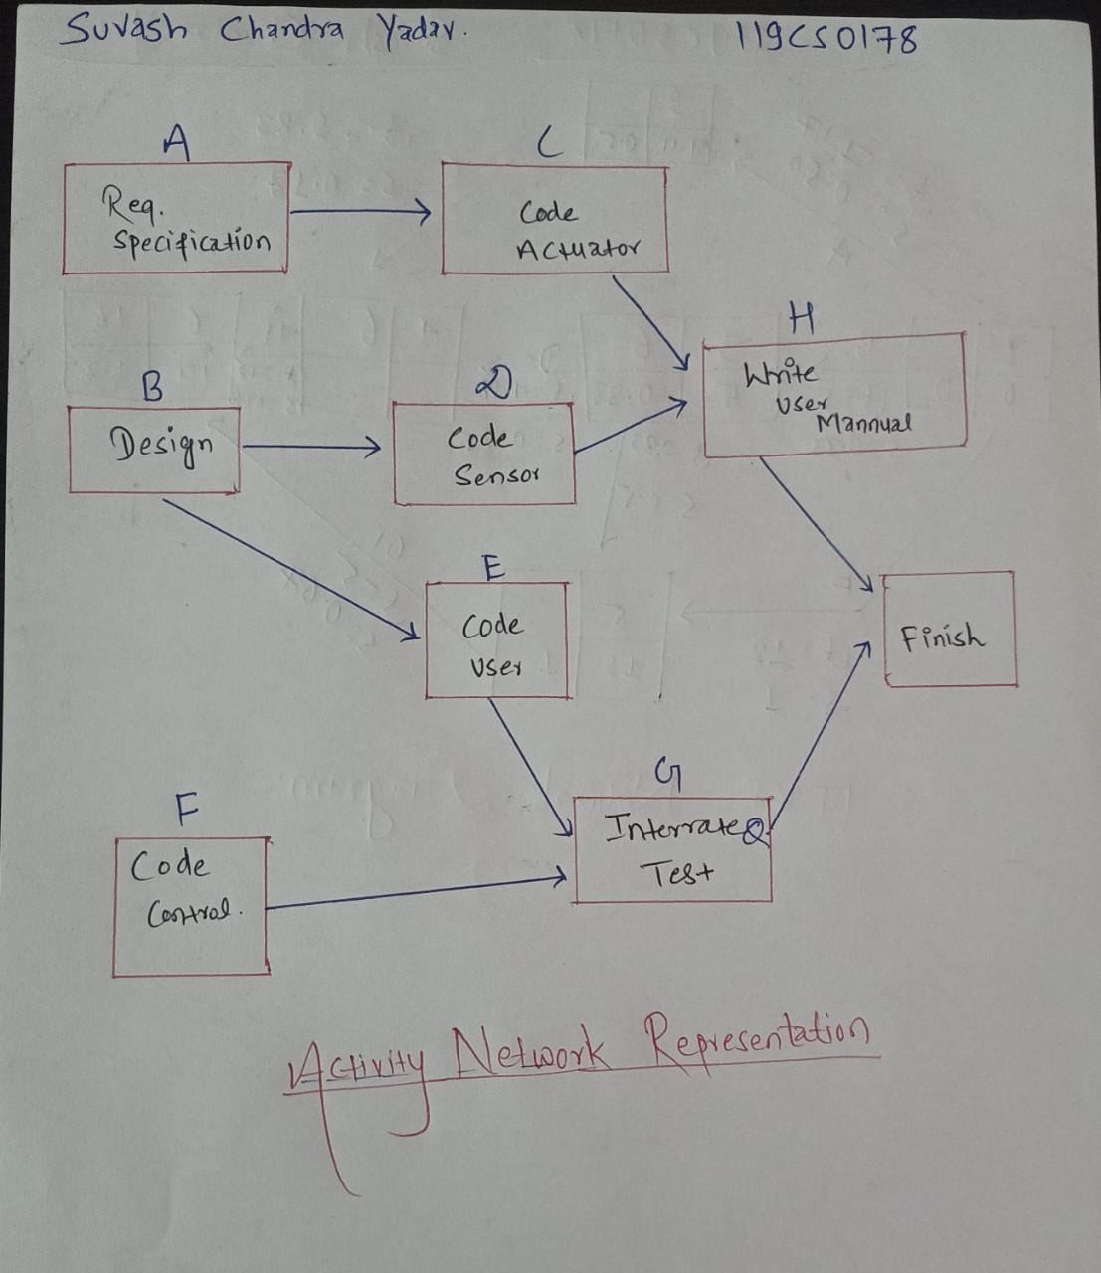

**Below is the table for Expected Time (Te):**

|  |  |  |  |  |  |
| --- | --- | --- | --- | --- | --- |
| **Activit y Label** | **Activity Name** | **Optimist ic(a)** | **Most Likely(m)** | **Pessimist ic(b)** | **Te** |
| A | Requirement  Specification | 6 | 7 | 9 | 7.17 |
| B | Design | 4 | 5 | 6 | 5 |

|  |  |  |  |  |  |
| --- | --- | --- | --- | --- | --- |
| C | Code Actuator | 2 | 3 | 3 | 2.83 |
| D | Code sensor | 3.5 | 4 | 5 | 4.08 |
| E | Code User | 2 | 4 | 5 | 3.83 |
| F | Code Control | 9 | 12 | 15 | 12 |
| G | Integrate and Test | 3 | 5 | 7 | 5 |
| H | Write User  Manual | 2 | 2 | 2.5 | 2.08 |

# Below is Table for Standard Deviation and expected time:

|  |  |  |  |  |  |  |
| --- | --- | --- | --- | --- | --- | --- |
| **Activit y Label** | **Activity Name** | **Opti misti c(a)** | **Most Likely(m)** | **Pessimisti c(b)** | **Te** | **Standard Dev. (s)** |
| A | Requirement  Specification | 6 | 7 | 9 | 7.17 | 0.5 |
| B | Design | 4 | 5 | 6 | 5 | 0.33 |
| C | Code Actuator | 2 | 3 | 3 | 2.83 | 0.17 |
| D | Code sensor | 3.5 | 4 | 5 | 4.08 | 0.25 |
| E | Code User | 2 | 4 | 5 | 3.83 | 0.5 |
| F | Code Control | 9 | 12 | 15 | 12 | 1 |
| G | Integrate and  Test | 3 | 5 | 7 | 5 | 0.67 |
| H | Write User  Manual | 2 | 2 | 2.5 | 2.08 | 0.08 |

* 1. **Below is the PERT network diagram showing every label value of the network:**

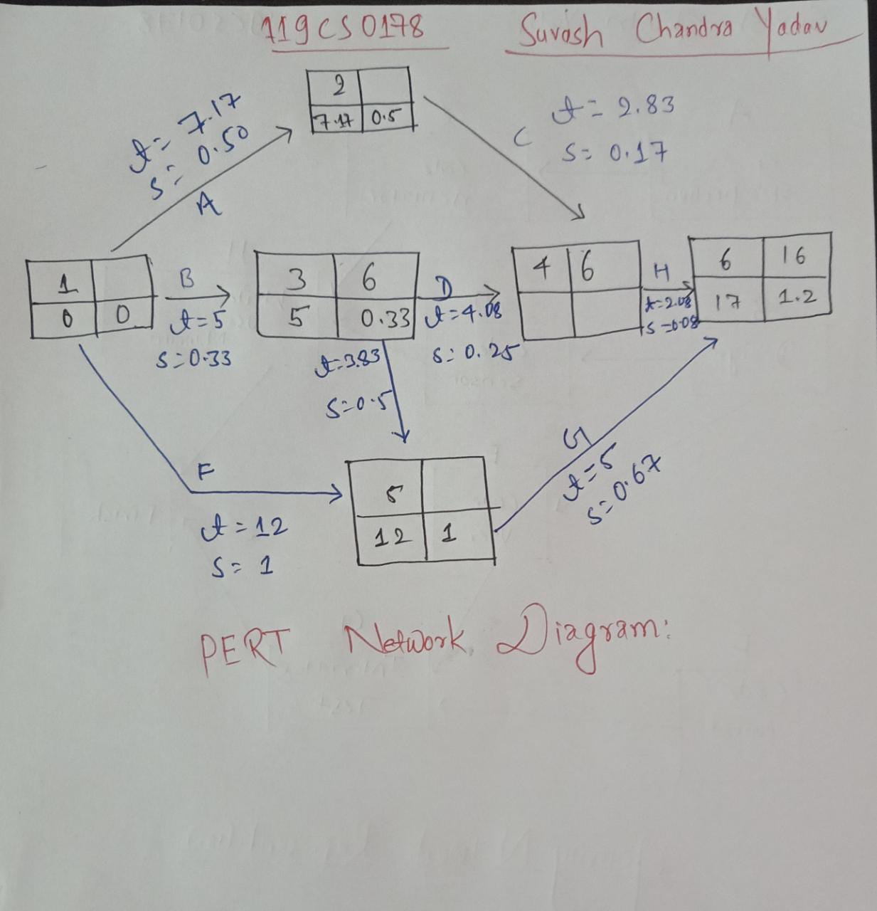

* 1. Z values for respective events:

***Event 3:***

z=(T-Te)/s

= (6-5)/0.33

= 3.

***Event 4 (for C and D):***

z=(T-Te)/s

=(6-10)/0.53

=-7.55

***Event 6(Completion of task):***

z=(T-Te)/s

=(16-17)/1.2

=-1/12

=-0.83

* 1. **What is the probability of completing the project by week 16?**

Probability of target being met in 16 weeks = 1-Φ(z(event 6))

= 1- Φ(-0.83)

= 1-(1- Φ(0.83))

= Φ(0.83)

=0.7967 {from normal table} So, there is **79.67%** chance that task will be completed in **16 weeks.**